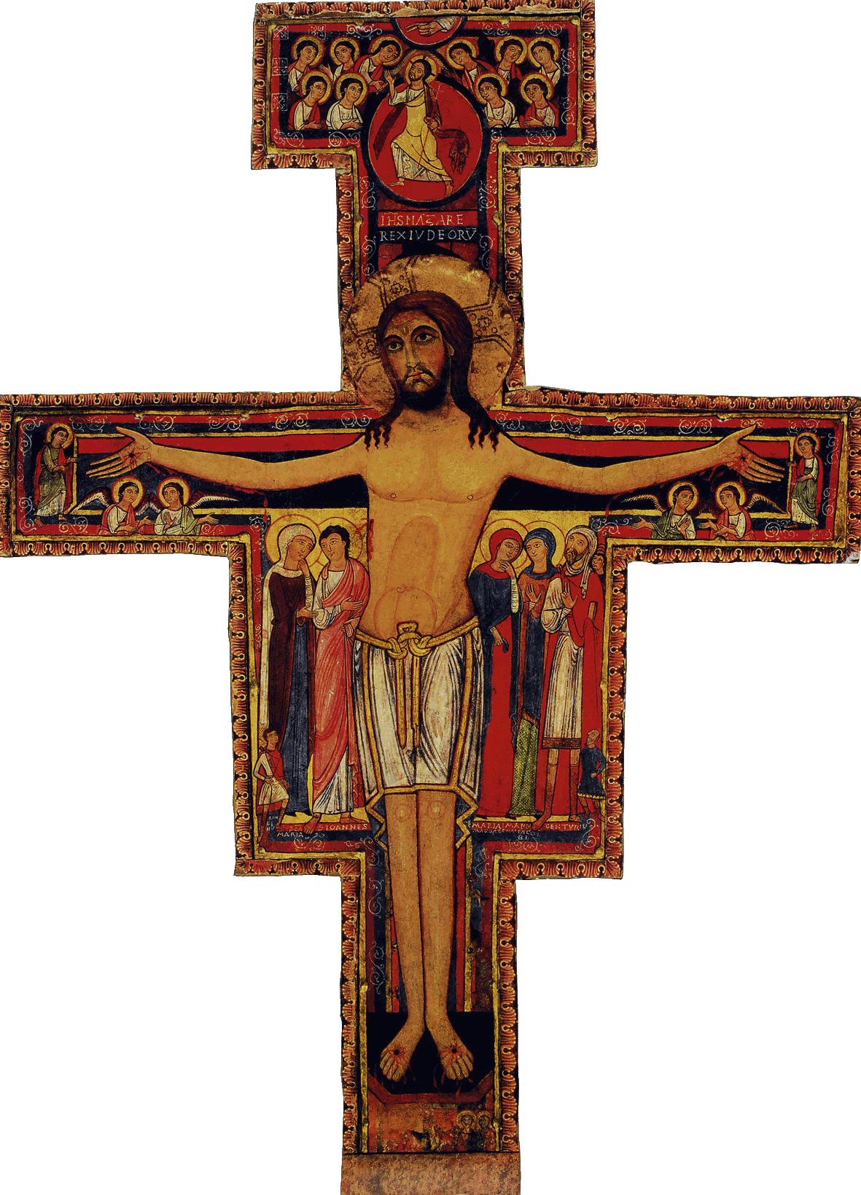

Initial Formation Program of the SFO of Canada

Workshop # 12: A life pledged towards justice, carried out by our work

Welcome

Opening Prayer/Song  The Word of God/Sharing | From the Ritual, or the Liturgy of the Hours, or the Prayers of Saint Francis or other Franciscan sources  Chant : Viens bâtir en Église…  Matt. 25, 31-45: «I was hungry… I was thirsty…»
Articles of the Rule (Life Project)  and of the General Constitutions  Content of the Formation taken from the CIOFS Formation Manual/Sharing  Franciscan Writings | Article 15 : A life pledged towards justice  Article 16 : A life carried out by our work  Re : article 15 of the Rule : G.C. - article 22  Re : article 16 of the Rule: G.C. article 21.1 and 21.2  Re : Article 15: see Formation Manual : excerpts from THE PROFESSION IN THE SFO : Secularity;  Excerpts from ECCLES. AND THEOLOGY; PROFESSION;  Re : Article 16: see Formation Manual : ECCLES. ET THEOLOGY : Essential Bibliography; Sources  1st Rule, 7, 4; 2nd Rule, 5.1
Pause

Other References such as Videos, CDs, DVDs, Films | Vatican II, art. 14; Gaudium et Spes  Spiritual Assistant Document (Green book): The lay condition  See : The dispute between the Bishop and the Chief Magistrate of Assisi
Optional : News/Announcements
Info. on the Church and Order

Formation Follow-up | 1.- Search in the writings of saint Paul, what he said about work  2. Note down the names of witnesses and organizations that have made a name for themselves in the fields of political, public and social life. How have they improved or profoundly influenced their milieu and their region?
Prayer/Parting Song

