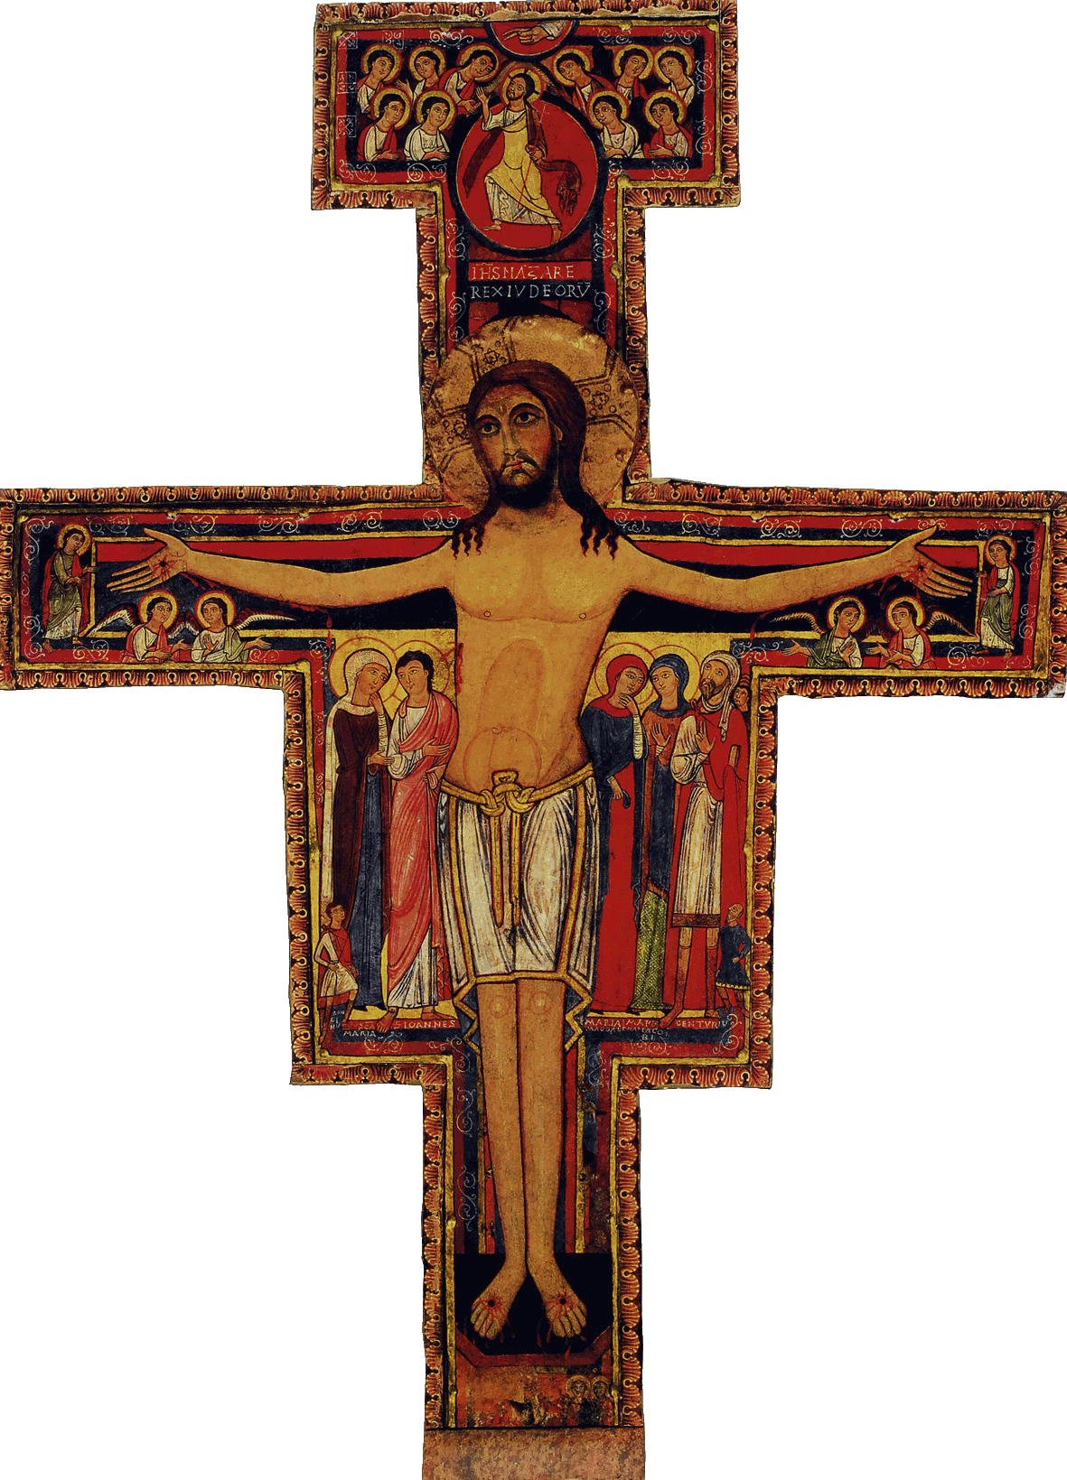

Initial Formation Program of the SFO of Canada
Introduction Files for Workshops

Welcome | Before the beginning of the meeting
Opening Prayer/Song  The Word Of God /Sharing | Choose and prepare the prayer and the hymn in accordance with the theme of the meeting, chosen from either the Daily Office of the FSO, or the Ritual, or the Prayers of Saint Francis  Chosen also in accordance with the theme and contents of the formation  Opening prayer, hymn and reading of the Word of God followed by a round table for about 30 minutes
Articles of the Rule (Life Project)  and of the General Constitutions  Contents of the Formation taken from the CIOFS Formation Manual  Sharing  Franciscan Writings | Profound meditation done in accordance with each article of the Rules, with the help of the proposed articles of the General Constitutions  Then a session of formation presented in a simple way but as complete as possible  References to the texts will be given, and if there are other relevant quotations, please inform the Director of National Formation who will then be able to share this information with you  Moments in the life of Saint Francis or of Saint Claire: Admonitions, Letters, etc.  About 50 minutes should be enough to cover this section and to include a time for sharing
Pause | At the most appropriate moment according to each group
Other References such as  Videos, CDs, DVDs, Films | Compendium of the Catholic Church; Catechism of the Catholic Church; Documents from the Council; Encyclopaedias. Other references? Il so, please inform the Director of National Formation
Optional: News/Announcements  Info. on the Church and Order | Birthdays; sick and/or deceased members; special news such as conferences; recollection days; Franciscan Heritage meetings or other meetings will be announced if there is no monthly meeting of the fraternity other than the meeting for the Initial Formation
Formation Follow-up | Keep a log-book to record the answers to the questions from the Director of Formation and to prepare also for the next topic
Prayer/Parting Song | Whenever possible, have the members share their thoughts before ending with a prayer and/or an appropriate hymn

