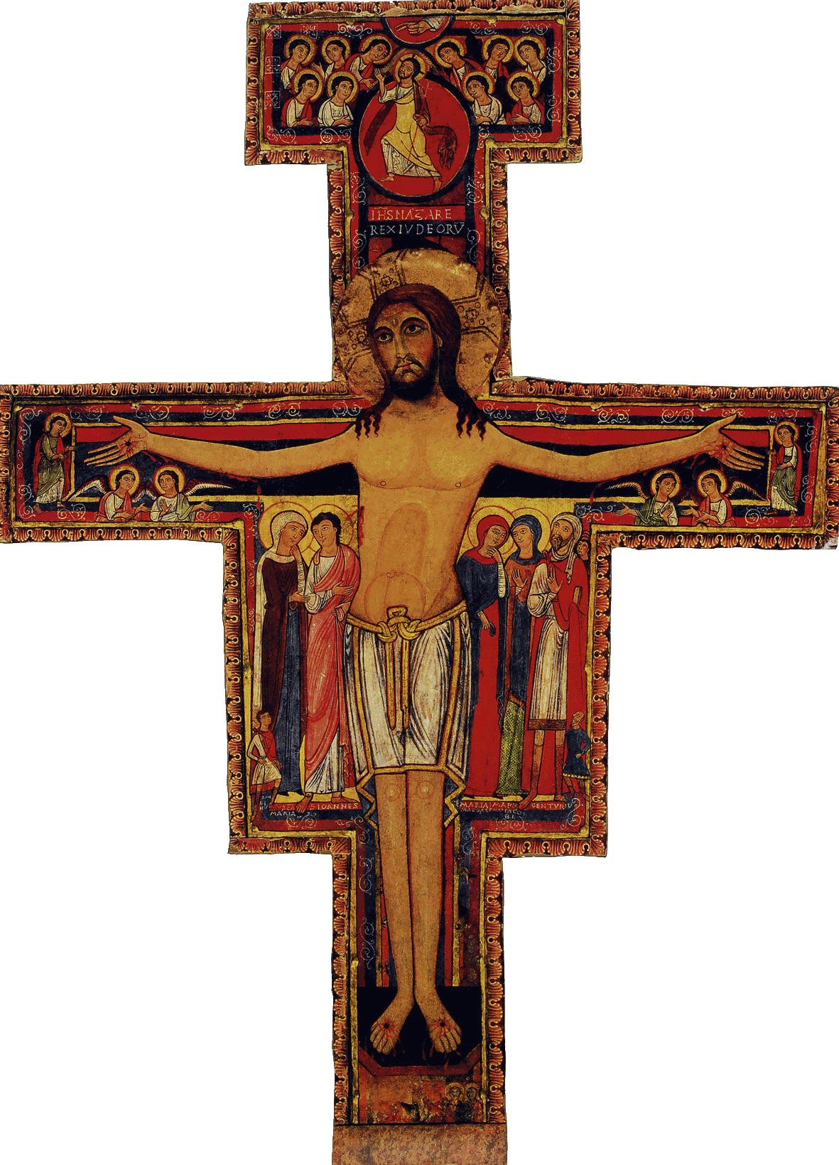

Initial Formation Program of the SFO of Canada

Workshop # 9: A life of poverty and humility, and a pure heart

Welcome

Opening Prayer/Song  The Word of God/Sharing | From the Ritual, or the Liturgy of the Hours, or the Prayers of Saint Francis or other Franciscan sources  Poverty and Humility: Rom 8, 17; Rom 8, 29; Mt. 6, 4; Luke 16, 13-16; Heb. 13, 5-6  Purity of Heart: Matt. 5, 3s.
Articles of the Rule (Life Project)  and of the General Constitutions  Content of the Formation taken from the CIOFS Formation Manual/Sharing  Franciscan Writings | Article 11 (Poverty and Humility); Article 12 (Purity of heart, purity of intention)  Article 15, 1.2.3 (Poverty and Humility)  Article 15.4 (Purity of heart)  Re : Poverty and Humility  Formation Manual: section GOD REVEALS HIMSELF  Re : Purity of heart  section GOD REVEALS HIMSELF  Saint Francis, Adm. 16; 1st letter, 70. First Rule, 25  Legend of the 3 Companions, Chapter III, no. 7 and 8; Saint Francis, First Letter to the Faithful, 5
Pause

Other References such as Videos, CDs, DVDs, Films

Optional : News/Announcements  Info. on the Church and Order | In Wisdom of a Poor One of Assisi,(paperback) by Éloi Leclerc, ofm, find what he says on the pure heart. Note the essential. http://www.amazon.com/Wisdom-Poor-One-Assisi/dp/093272745X#_  Invite the candidates to express their opinions on voluntary simplicity.
Formation Follow-up

Prayer/Parting Song

